VETERANS OF FOREIGN WARS AND AUXILIARY
DEPARTMENT OF WEST VIRGINIA
VFW BUDDY POPPY ORDER FORM

NAME: ___________________________________________________________________
(Must be the name of an individual, not a Post or Auxiliary name)

Ordered by: POST OR AUXILIARY

ADDRESS WHERE POPPIES WILL BE SHIPPED:

(Street) (City) (State) (Zip Code)

Minimum number of traditional or Poppy tabs that can be ordered is 500

Traditional Buddy Poppies:
Number of Poppies ______ $275 per 1,000, (plus shipping per chart below) $

_______ $167 for 500 (plus $15.95 shipping) $_________________

Buddy Poppy Tabs:
Number of Tabs ________ $70 per 500 (plus shipping per chart below) $_________________

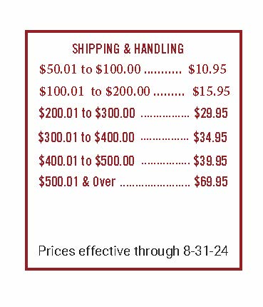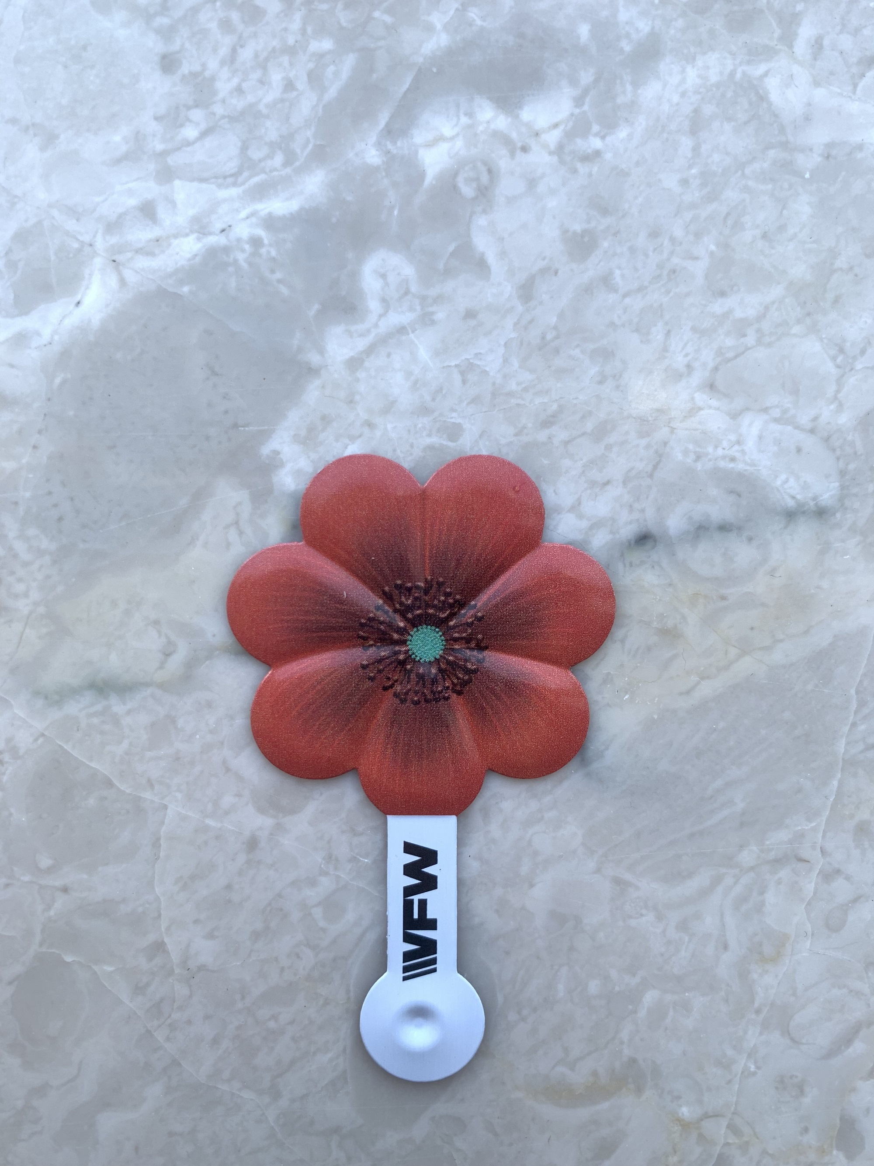

Signed:

Name Title
NOTE: ALL ORDERS MUST BE SENT TO THE STATE HEADQUARTERS.
Make checks payable to: VFW STATE OF WEST VIRGINIA

Send all Orders and checks direct to:
VFW State of West Virginia
PO Box 9431
South Charleston, WV 25309

(Rev. 10/19/2023)

