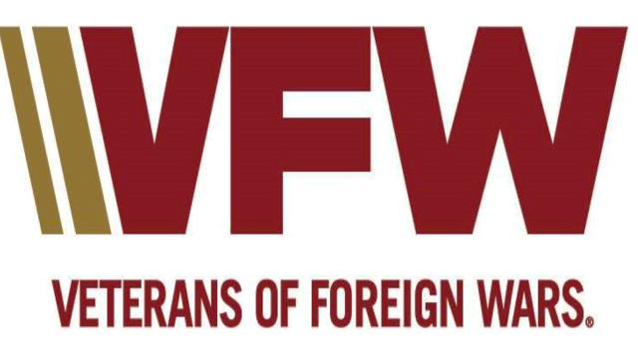

DEPARTMENT OF WEST VIRGINIA
POLICY DIRECTIVE NO. 1
SOCIAL MEDIA AND INTERNET POLICY

PURPOSE: This policy sets forth guidelines for the use of social media and internet for any online medium where information may reflect on the image of the VFW, any VFW personnel and its clients. This Social Media Policy applies to all offices of the VFW and to all VFW Personnel. VFW Personnel means all Officers, Members, Auxiliary Members, staff members, interns, volunteers, temporary employees of VFW and agents acting on behalf of the VFW (shall be referred to individually or collectively as "VFW")

AUTHORITY: The Social Media Policy describes the guidelines adopted by the Council of Administration, Department of West Virginia, Veterans of Foreign Wars of the United States. The VFW is subject to rules under the following government regulations, but not limited to, Internal Revenue Code 501C, The Office of Civil Rights Health Insurance Portability and Accountability Act of 1996 (HIPAA), Equal Employment Opportunity Commission (EEOC) and other local, state and federal laws. VFW National Headquarters General Orders No. 7, Series 2025-2026, provides additional guidance.

SCOPE: Generally, these guidelines set forth in this policy should be applied to any online medium where information may reflect the image of the VFW, but not limited to blogs, Facebook, MySpace, Wikipedia or other wikis, Twitter and Linkedln. These guidelines also apply to any comments VFW Personnel may leave on others' blogs or Facebook/MySpace pages, edits to wikis, responses to tweets, postings on message boards/forums, opinions on online polls or any product/services VFW Personnel might author or photos taken and tagged with themselves or others.

POLICY: Most conversations on social media platforms are held in an informal manner, so strict application of the VFW writing style is not required for social media communications. However, professional discourse is expected. The primary focus of this policy is avoiding the unique pitfalls online communication holds for veteran service and charitable foundation professionals. In view of these facts, below are guidelines and a list of things to avoid when communicating with the public via any social media outlet.
All social media accounts, blogs, Web pages and related content carrying the VFW brand identity are and will be owned and licensed by VFW as appropriate. Personal accounts, blogs, Web pages and related content that do not carry the VFW brand identity can be owned, licensed and operated by any VFW Personnel. However, all use of VFW's name, logo and/or related marks requires prior, express, written consent of the VFW. If the VFW is referenced in any media, all social media guidelines apply.

Guidelines:

- The Internet is not anonymous, nor does it forget. Everything written on the Web can be traced backed to its original author. Information is backed up often and repeatedly, and posts in one forum are usually replicated in others through reposts or references.

- There is no clear line between your work life and your personal life. Always be honest and respectful in both capacities. With the ease of tracing authors back from their posts and the amount of information online, finding the actual identity of a poster from a few posts and a screen name is not impossible. This creates an avenue for outside parties to link your personal writings to those you've done in a professional capacity. Always write as if everyone knows you. Never write anything you wouldn't say in-person to all parties involved.

- Avoid hazardous materials. Do not post or link to any materials that are defamatory, discriminatory, harassing, or indecent.

- Don't promote other brands with the VFW brand. Do not promote personal projects or endorse brands, political affiliation, causes, or opinions when posting from a VFW or personal account using the VFW name or logo. Be sure to respect third party copyrights. If an opinion must be posted, clearly state to all readers that it does not represent the opinions of the VFW.

- Maintain confidentiality. Do not post any confidential or proprietary information regarding the VFW, its clients (e.g., client confidences, insider information, and VFW financial information) and vendors. This also means that the personal information of the employees and other individuals associated with the services that we deliver to our clients (e.g., members, applicants) and our own VFW Personnel should not be shared on or disclosed through social media under any circumstances.

- Don't pad your own stats. Do not create anonymous or pseudonym online profiles to pad link or page view stats. Also do not comment on your own or another's posts to create a false sense of support.

- Always track back. When reposting or referencing a post on one of VFW's online sites, provide a link to the original post or story.

- Identify yourself. Do not hide your identity with a post or district name. Use of your personal identification is highly requested. When relevant, identify your affiliation with VFW and your area of concentration. This will add credibility to your profile and increase VFW's profile/communications.

- Post or District Social Identities. The post or district webmaster may create post or district accounts (Facebook, Twitter) for further distribution of their post/district activities. Posting to these accounts will be done by linking your post or district website stories to your post or district pages.

- Do not return fire. If a negative post or comment is found online about VFW or yourself, do not counter with another negative post. Instead, publicly offer to remedy the situation through positive action. Seek help from the State Adjutant's office in defusing these types of situations.

- Do not offer or appear to offer legal advice. We should not give legal advice or otherwise form what can be perceived as attorney-client relationships using social media. Formation of these relationships must be done only through our regular procedures to avoid conflicts and other ethical problems.

- No Politics allowed. Addressing issues, yes, but post your political views on your own page, not on VFW pages. The Veterans of Foreign Wars name and insignia, including but not limited to official caps, shirts, jackets, patches, emblems, or any other garments or items identifying affiliation with the VFW, shall not be worn at rallies, protests, demonstrations, court proceedings, or events supporting or opposing individuals or entities involved in alleged criminal activity, legal proceedings or other sensitive public controversies. Members should refrain from posting photographs, videos, comments, or other content on social media platforms. Any member choosing to attend such events or support these activities must do so strictly in a personal capacity and shall not reference, imply, or otherwise represent the Veterans of Foreign Wars of the United States in any manner.

Even when attending in a purely personal capacity, the presence of VFW identifiable material can create the public perception that the organization itself is endorsing or opposing a particular cause or position which is strongly discouraged. The VFW is a nonpartisan organization and maintaining that neutrality is essential to preserving our credibility, unity, and standing in the communities we serve. Each of us retains the right to express personal views as private citizens; we simply ask that members do so without the use of VFW-identifying attire or insignia.

- Site Ownership and Passwords. All VFW Post, District and Department Social Media Sites of all types include Facebook, Twitter, blogs, webpages, or any other media sites that represent any VFW location, whether started by a private individual or not, if it officially represents that location will follow the below policy.

- All login credentials will be provided to the Post Commander or designated representative upon setup, and as passwords are changed.
- Billing information will be provided to the appropriate Quartermaster.

Summary: If in doubt about what you want to post on your site, you may always contact the State Adjutant for an interpretation and authorization prior to posting.

Cancellation: The Policy and Procedure contained herein is issued for guidance to Department of West Virginia members to utilize and will remain effective until cancelled or superseded.

APPROVED BY COUNCIL OF ADMINISTRATION ON: _____________________

By Order of

Corrina M. Boggess
Commander, Department of West Virginia
Veterans of Foreign Wars of the United States

Attest:

David A.J. Sockett, Adjutant

